Learn the following terminology below. Use the terminology to label the diagram below.

Abdominal: The anterior body trunk region inferior to the ribs
Antecubital: The anterior surface of the elbow
Axillary: The armpit
Brachial: The arm
Buccal: The cheek
Carpal: The wrist
Cervical: The neck region
Coxal: The hip
Deltoid: The roundness of the shoulder caused by the underlying deltoid muscle
Digital: The fingers or toes
Femoral: The thigh
Fibular: The side of the leg
Inguinal: The groin
Mammary: The breast
Manus: The hand
Nasal: The nose
Oral: The mouth
Orbital: The bony eye socket (orbit)
Patellar: The anterior knee (kneecap) region
Pelvic: The pelvis region
Pubic: The genital region
Sternal: The region of the breastbone
Tarsal: The ankle
Thoracic: The chest
Umbilical: The navel
Posterior Body Landmarks
Identify and appropriately label the following body surface regions in Figure 1 b:
Cephalic: The head
Gluteal: The buttocks or rump
Lumbar: The area of the back between the ribs and hips; the loin
Occipital: The posterior aspect of the head or base of the skull
Popliteal: The back of the knee
Sacral: The area between the hips
Scapular: The scapula or shoulder blade area
Sural: The calf or posterior surface of the leg
Vertebral: The area of the spinal column

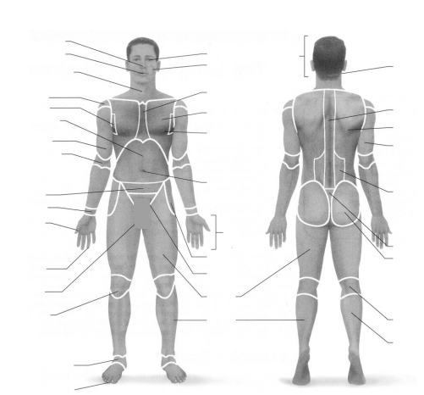

Part B. Practice Using Correct Anatomical Terminology
Use the diagrams located under the Zoology website to answer the practice questions.
Before continuing, use a human torso model, a skeleton, or your own body to specify the relationship
between the following structures.
1. The wrist is ________________ to the hand.
2. The trachea (windpipe) is ______________ to the spine.
3. The brain is ________________ to the spinal cord.
4. The kidneys are _________________ to the liver.
5. The nose is to _______________ the cheekbones.
6. The chest is _____________________ to the abdomen.
7. The skin is ____________________ to the skeleton.

